Hydrologic Effects of Mountain Pine Beetles

Handout for Community Stewardship Workshop
Pat Teti
May 19th, 2007

Retention of dead stands versus salvage logging

If an attacked stand is left to natural processes, hydrologic change will be gradual as trees deteriorate and fall to the ground over a period of decades. During this time, understory vegetation will release due to higher light levels and lower competition for water and nutrients. In contrast, salvage logging results in a large immediate change in hydrologic processes. For example, logging immediately eliminates the interception of rain, snow and shade. This changes the amount and timing of water inputs to the ground and rates evaporation and snowmelt.

The effects of retention versus salvage logging will be different after a number of years due to deterioration of dead trees and growth of new trees. The two cartoons below illustrate the types of changes that could occur in an attacked stand and a logged stand over about 20 years. Predicting the differences between attacked stands and plantations several decades in the future is an area of active research.
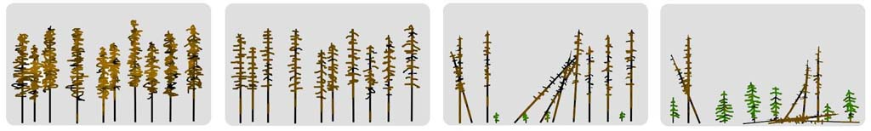

Changes in an attacked stand over time

The future condition of these stands will vary depending on factors such as the species mix, the intensity of attack, the presence of understory, and how fast the trees blow down.



Changes in a logged and reforested stand over time

The future of these stands is also uncertain due to climate change and reliance on a single species.

Scientific Literature

Dr. Rita Winkler maintains a searchable library of abstracts on forest hydrology at
http://foresthydrology.gov.bc.ca/
There are only a few scientific publications which document hydrologic changes due to an intense beetle infestation. In contrast, there is a large body of literature on the effects of clearcutting. Therefore, we are more certain about the effects of salvage logging than we are about the effects of beetles alone.

Bethlamy (1975) found that spring runoff increased by 10 to 30 percent after 30 percent of spruce trees were killed by beetles in the White and Yampa River watersheds of Colorado.

Website on the sensitivity of watersheds to the beetle infestation (2007)
Discusses hydrologic effects of beetles. Has pdf maps and Excel spreadsheets showing percent area of pine and percent area logged in third-order watersheds.
http://www.for.gov.bc.ca/hfp/mountain_pine_beetle/stewardship/hydrology/
Note:
If you want to view these websites, it may be easier to find them in Google rather than typing in the URL’s. You can find most of these sites by searching for “mountain pine beetle hydrology” (without the quotes).

MPB Salvage – Hydrology recommendations (2004)
Contains recommendations for minimizing the hydrologic impacts associated with salvage logging
www.for.gov.bc.ca/hfp/mountain_pine_beetle/stewardship/Hydrological%20Recommendations%20Dec%203%202004.pdf

Chief Forester's Response to Potential MPB related Flooding (2007)
www.for.gov.bc.ca/hfp/mountain_pine_beetle/stewardship/Chief_Forester_Hydrology_200703.pdf

Hydrologic Effects of Mountain Pine Beetle in the Interior Pine Forests of BC: Key Questions and Current Knowledge
Article in Streamline Watershed Management Bulletin (2006)
www.forrex.org/streamline/ISS31/streamline_vol9_no2.pdf

The effect of Mountain Pine Beetle attack and salvage harvesting on streamflows, a Special Investigation by the Forest Practices Board
Based on a computer watershed model, the combined effect of beetles and salvage logging could result in flood peaks on Baker Creek west of Quesnel nearly doubling within 10 years. This includes the smaller flood peaks as well as those that occur on average only once every 20 to 50 years.
www.fpb.gov.bc.ca/special/investigations/SIR16/The_Effect_%20of_%20Mountain_%20Pine_%20Beetle_%20Attack_%20and_%20Salvage_%20Harvesting_%20on_%20Streamflows_SIR16.pdf

Workshop Announcement
Mountain Pine Beetle and Watershed Hydrology Workshop:
Preliminary Results of Research from BC and Alberta
Date: July 10, 2007
Location: Ramada Inn, Kelowna, BC
www.selkirk-management.com/mpb_and_water_hydrology.html

